Send Logs to S3 from ASG at termination

There are few methods, we can send EC2 logs to S3 at the time of termination,

* Using **Lamda**
  + - 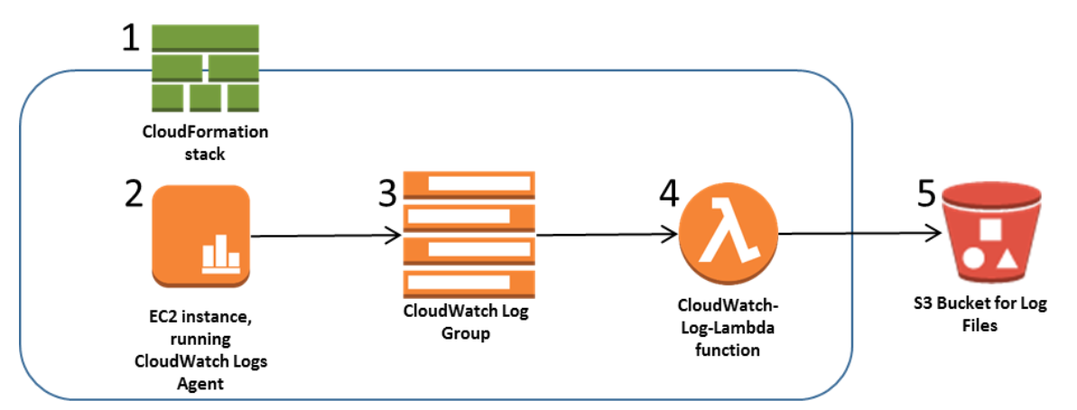
* Using “**logrotate-and-s3cmd**”

1. Here in this process I went through 2nd option (**logrotate-and-s3cmd),**  Since it is Cost efficient and Resilience, and Loadbalancer etc.

The below is a simple structure, to make even it resilience , We can launch instances in different AZs and can place instances in public and Private Subnets.

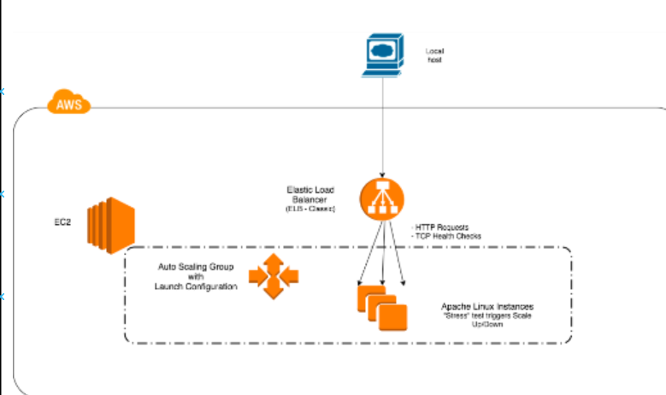

1. Created S3 bucket with name “[logsfromec2-12-22-2020](https://s3.console.aws.amazon.com/s3/buckets/logsfromec2-12-22-2020?region=ap-south-1)”

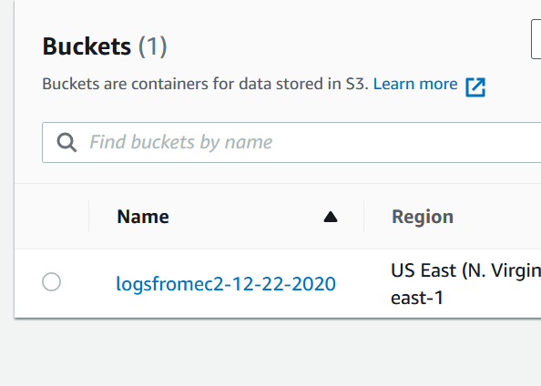

1. Created a LoadBalancer and target groups here. And didn’t attached any Target groups at first.

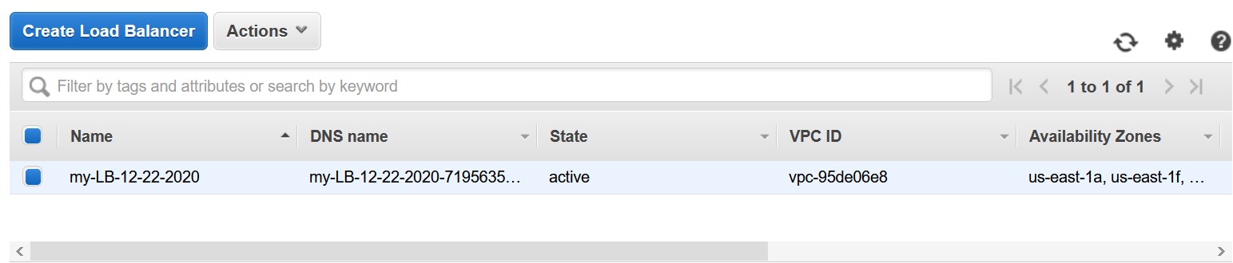

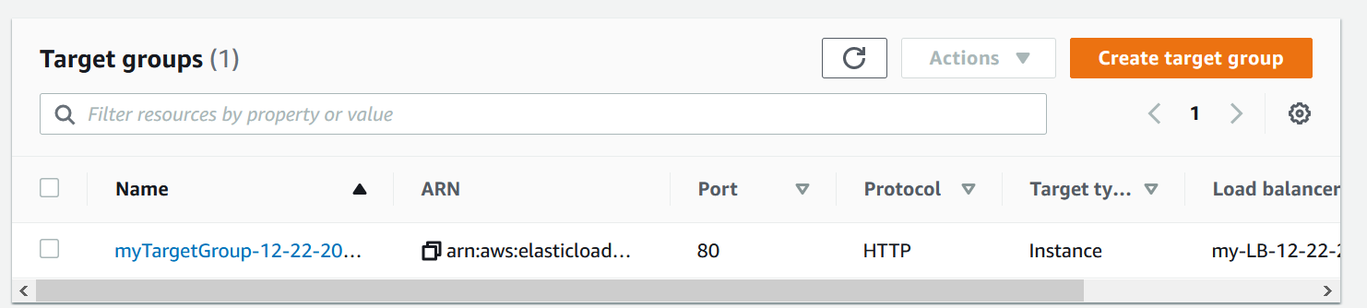

1. Created ASG template and ASG.

Here you can choose AMI, instance type, security groups, keypair name etc.

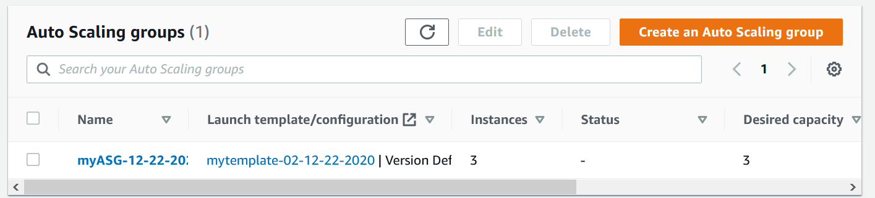

Once we created the template go to the Auto Scaling group, give “Auto Scaling group name” and then choose the template which we created in above step.

Choose the options as showing, like VPC, Subnets, then attach the Load Balancer (**Attach to an existing load balancer, which we created**) to it.

Taken min, max, desired as below, we can choose/Edit as required

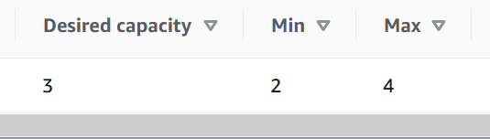

1. You can Cross check the instances status in target groups.

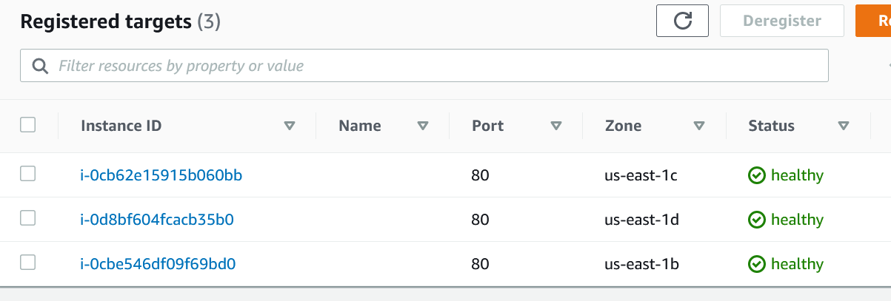

1. We can see Instances having 3 instances running from console.

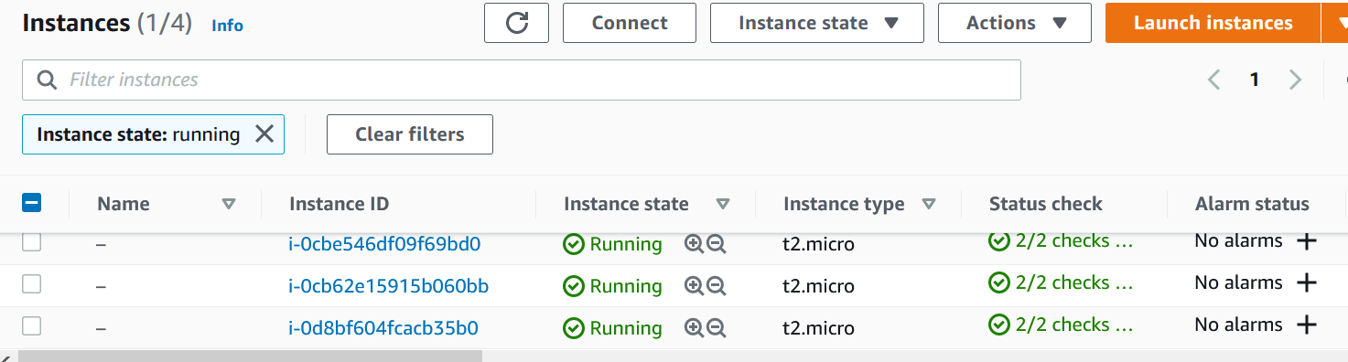

1. Since our aim is to send the logs to S3 bucket before terminate, im going to terminate one of the EC2 instance.

Below is the S3 files which already stored.

There **are 7 Objects** are there in S3 now

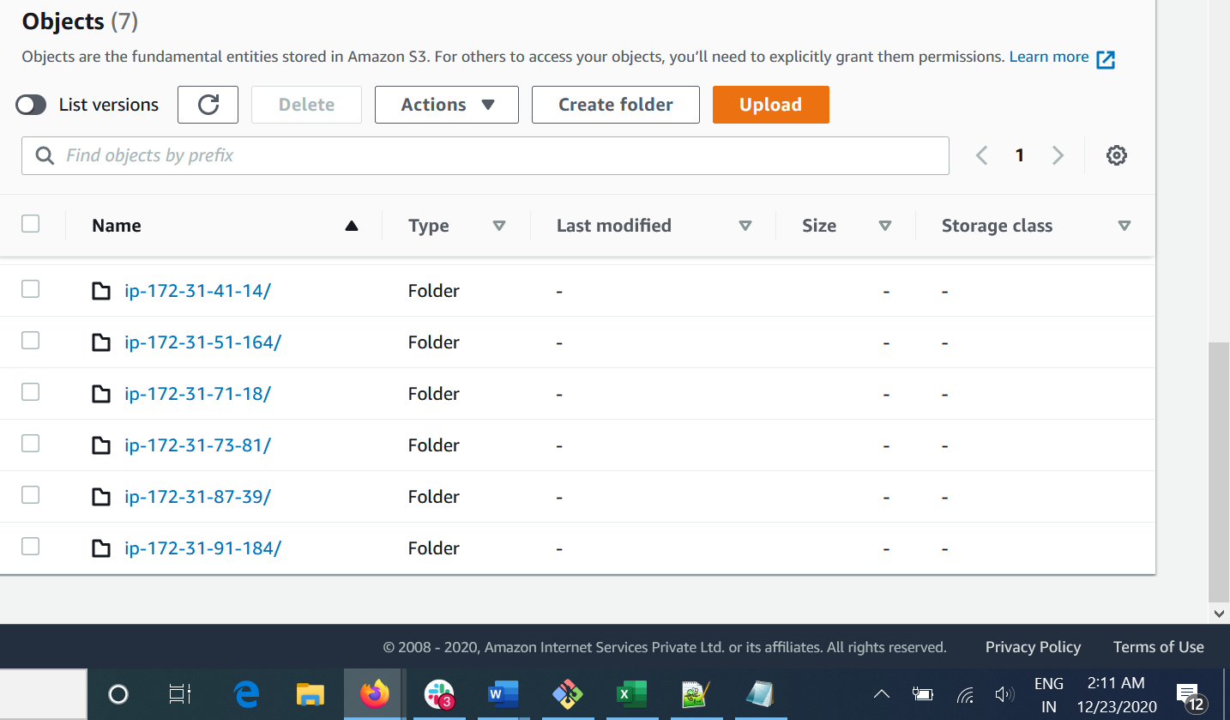

1. Now I’m going to terminate one of the instances.

We can see that one of the instance has IP of “54-89-187-105” , terminated

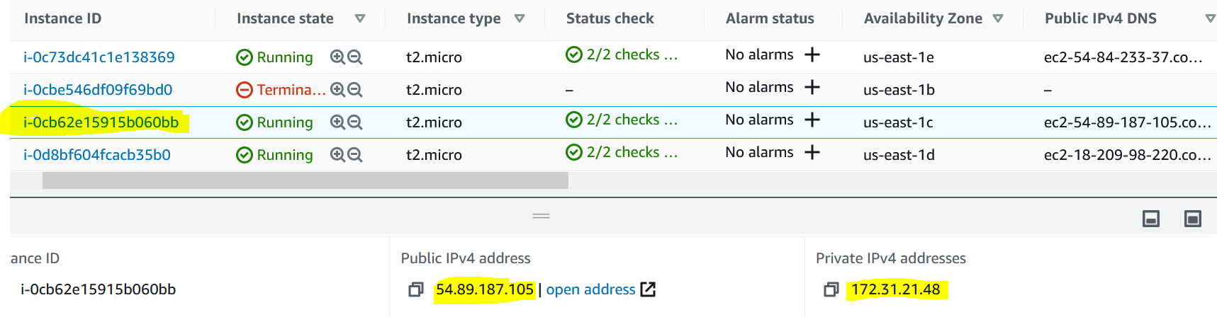

1. We can see that **a file has been auto created in S3 with Ip ending 48**

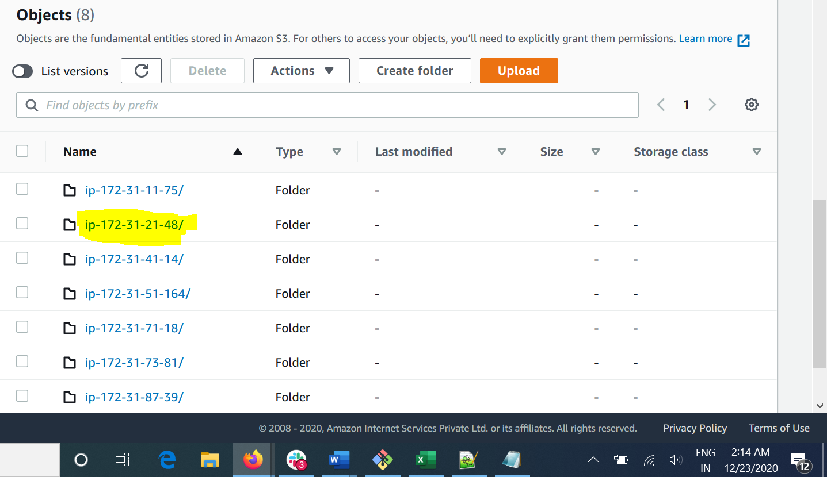

1. Since we have set up Auto scaling a new EC2 instance got created automatically

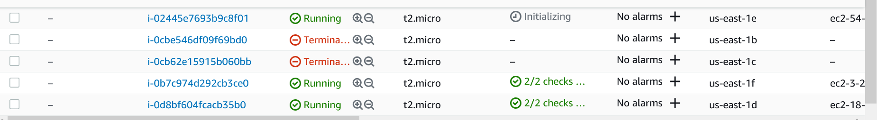

1. Inside the IP folder, We can see the logs

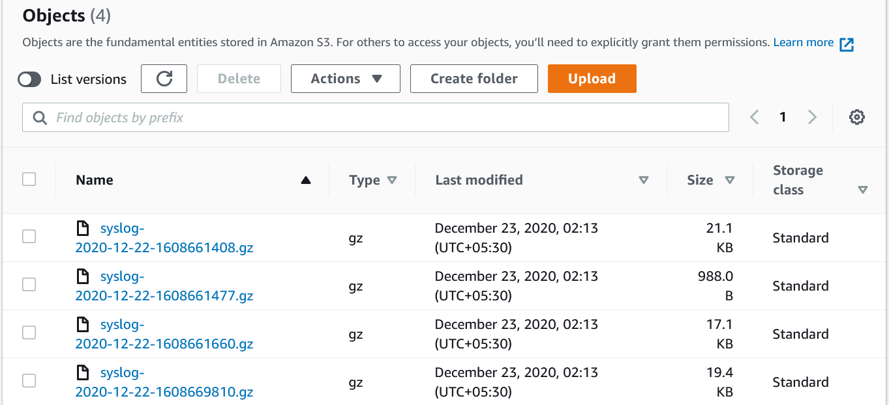

1. Since We have configured the load balancer we have equal traffic routing using Load Balancer DNS

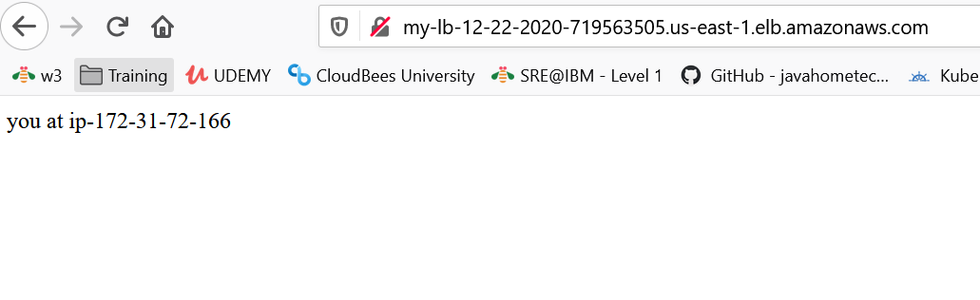

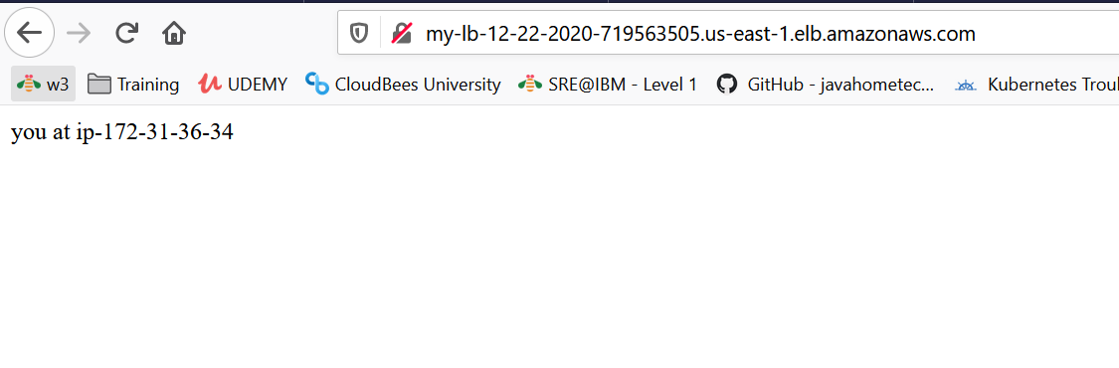



1. Have created ROUTE 53 for the Load Balancer, with CNAME, A and NS records and pointed to Domain [www.mydomaintesting.store](http://www.mydomaintesting.store).

There are 7 Route 53 policies are there, based on the requirement we can choose anyone.

copied the AWS-NS from Route 53 to Domain. ( seems NS details not accepting by hostinger, need to check with them ), but process is same

We can buy **HTTPS and Domain** **Name** directly from AWS or can go outside like GoDaddy, Hostinger, etc…

**Below is the configuration which I did in EC2 Instance:**

1. First Need to have Access and Secret key, Server (or “Endpoint”) URL, Bucket Name.
2. sudo apt-get update
3. sudo apt-get install python-setuptools
4. cd /tmp
5. curl -LO <https://github.com/s3tools/s3cmd/releases/download/v2.0.1/s3cmd-2.0.1.tar.gz>
6. tar xf s3cmd-*.tar.gz
7. cd s3cmd-*
8. sudo python setup.py install
9. Test the install by asking s3cmd for its version information:

s3cmd –version

You should see Output as “s3cmd version 2.0.1”

1. Configuring S3cmd

Use this command and configure

sudo s3cmd --configure --config=/root/logrotate-s3cmd.config

Access Key: your-access-key

Secret Key: your-secret-key

Default Region [US]: ENTER

S3 Endpoint [s3.amazonaws.com]: nyc3.digitaloceanspaces.com

DNS-style bucket+hostname:port template for accessing a bucket [%(bucket)s.s3.amazonaws.com]: %(bucket)s.nyc3.digitaloceanspaces.com

Encryption password: ENTER, or specify a password to encrypt

Path to GPG program [/usr/bin/gpg]: ENTER

Use HTTPS protocol [Yes]: ENTER

HTTP Proxy server name: ENTER, or fill out your proxy information

The Output should come as below:

Output

Test access with supplied credentials? [Y/n] y

Please wait, attempting to list all buckets...

Success. Your access key and secret key worked fine :-)

1. Setting up Logrotate to Send Rotated Logs to Object Storage.

sudo nano /etc/logrotate.d/rsyslog

/var/log/syslog

{

rotate 7

daily

missingok

notifempty

compress

postrotate

invoke-rc.d rsyslog rotate > /dev/null

endscript

dateext

dateformat -%Y-%m-%d-%s

lastaction

HOSTNAME=`hostname`

/usr/local/bin/s3cmd sync --config=/root/logrotate-s3cmd.config /var/log/syslog*.gz "s3://your-bucket-name/$HOSTNAME/"

endscript

}

1. Cross check whether S3 logs are uploading to S3 with below command

sudo logrotate /etc/logrotate.conf --verbose --force

the output should be like:

upload: '/var/log/syslog-2017-11-08-1510175806.gz' -> 's3://example-bucket/example-hostname/syslog-2017-11-08-1510175806.gz' [1 of 1]

36236 of 36236 100% in 0s 361.16 kB/s done

1. Now configure Sending Logs on Shutdown.

sudo nano /etc/systemd/system/logrotate-shutdown.service

Add the below content in it.

|  |
| --- |
| [Unit]  Description=Archive logs before shutdown  After=network.target  [Service]  RemainAfterExit=yes  ExecStop=/usr/sbin/logrotate /etc/logrotate.conf --force  [Install]  WantedBy=multi-user.target |

Run the belo commands to restart and enable Logrotate service.

1. sudo systemctl start logrotate-shutdown.service
2. sudo systemctl enable logrotate-shutdown.service
3. sudo systemctl status logrotate-shutdown.service
4. sudo systemctl stop logrotate-shutdown.service ( this sends the logs to S3 bucket )

And the logic for the other Assignment what is guessing was, not sure about this but I need some time to figureit out.



There will be a **DB** which has write and read replicas,

The Ai (Python with OpenCV) should save the info of the CAR if it violates traffic Rules along with charges which we already has in the code (charges wont change randomly or daily).

So now we have a data with car violated along with Charges attached to it in last column.

Next time when the AI see the car in the Traffic signal , it should compare the data which it already has and send the notification using **GeoPy (nearby loc police)**

import cv2  
import numpy as np  
import time  
import vehicles